12576 - Nisanth Saravanan
L1 Type Script Assessment

Real-Time Traffic Monitoring System

Case Study:
This system provides real-time traffic data to help authorities manage road congestion and inform drivers of traffic conditions.

Entity:
TrafficReport

Required Fields:
ReportId, Location, TrafficDensity, AverageSpeed, IncidentDetails

GitHub URL:

Nisanth-Saravanan/L1_TypeScript_Assessment

W3H Analysis

Project Title: Real-Time Traffic Monitoring System
What? |  | How?
1.What are the Modules/Functionalities needed?  A: Modules/Functionalities Required:  a) Landing Component.  b) Reporting Component.  c) Display Functionality.  d) Search Functionality.  e) Delete Functionality.  f) Update Functionality.  2. What are the requirements of Landing Component?  A: Landing Component:  a) Greet the user with a custom message.  b) Redirect or Render in the Reporting Component.  c) Return back to Landing Component.  3. What are the requirements of the Reporting Component?  A: Reporting Component:  a) Get User Input.  b) Validate user input.  c) Inject new data into the JSON file.  4. What are the requirements of the Display functionality?  A: Display Functionality:  a) Display user data.  b) Provide means to search.  c) Provide means to update.  d) Provide means to delete.  5. What are the requirements of the Search functionality?  A: Search Functionality:  a) To search the Reporting based on Reporting ID.  b) To display search results.  6. What are the requirements of the Delete Functionality?  A: Delete Functionality:  a) To delete the Reporting selected.  7. What are the requirements of the Update Functionality?  A: Update Functionality:  a) To update the Reporting selected.  b) To validate the update. |  | 1. Landing Component:  a) Greet the user with a custom message:  Method 1: Use simple container to greet the users in a landing page.  Method 2: Greet users in an alert.  Method 3: Have a series of prompts that lead the user to add a Reporting by default.  b) Redirect or Render in the Reporting Component.  Method 1: Have a dedicated Navigation Bar.  Method 2: Have simple buttons to render in the component.  Method 3: Have the user be automatically redirected to the component.  c) Return back to Landing Component.  Method 1: Have a dedicated Navigation Bar.  Method 2: Have simple buttons to render in the component.  Method 3: Have the user refresh the page to revisit the landing page.  2. Reporting Components:  a) Get User Input:  Method 1: Have a simple form.  Method 2: Use a series of prompts.  Method 3: Use modular forms with optional modules.  b) Validate User Input:  Method 1: User JS validations and alerts.  Method 2: Use default validations.  Method 3: Use JS validations and HTML elements.  c) Inject new data into JSON file:  Method 1: Use Async Axios.  Method 2: Use Redux.  Method 3: Use Sync Axios.  3. Display Functionality:  a) Display user data:  Method 1: Display as table.  Method 2: Display as cards.  Method 3: Display as detailed <div>’s  b) Provide means to search:  Method 1: Use a button and prompts.  Method 2: Use input field and ask id.  Method 3: Render a separate component.  c) Provide means to update:  Method 1: Use a button and the input field.  Method 2: Use input field and ask id.  Method 3: Render a separate component.  d) Provide means to delete:  Method 1: Use a button and alerts.  Method 2: Use input field and ask id.  Method 3: Render a separate component.  4.Search Functionality:  a) To search the Reporting based on Reporting ID:  Method 1: Use prompt and ask for unique Reporting ID.  Method 2: Use Input field and ask for unique Reporting ID.  Method 3: Use range filters.  b) To display search results:  Method 1: Use prompts.  Method 2: Use cards.  Method 3: Re-render the table.  5.Delete Functionality:  a) To delete the Reporting selected:  Method 1: Use a simple button next to a Reporting.  Method 2: Use input field and ask for id.  Method 3: Use filters to select a Reporting.  6. Update Functionality:  a) To update the Reporting selected:  Method 1: Use prompts to get user input.  Method 2: Use form’s input field.  Method 3: Render a separate component for updating.  b) To validate the update:  Method 1: User JS validations and alerts.  Method 2: Render components to showcase validations.  Method 3: Use JS validations and HTML elements.
1. Landing Component:  a) Greet the user with a custom message:  Method 1: Use simple container to greet the users in a landing page.  A: Having to use a simple landing page give a soft welcome to our app.  b) Redirect or Render in the Reporting Component.  Method 1: Have a dedicated Navigation Bar.  A: Gives an easy approach for accessing the needed component.  c) Return back to Landing Component.  Method 1: Have a dedicated Navigation Bar.  A: Gives an easy approach for accessing the needed component.  2. Reporting Components:  a) Get User Input:  Method 1: Have a simple form.  A: Efficient and can be easily handled to our requirements.  b) Validate User Input:  Method 1: User JS validations and alerts.  A: Gives an efficient, yet effective means of validations.  c) Inject new data into JSON file:  Method 1: Use Async Axios.  A: The async axios gives an assurance to not loose data under varying data speeds.  3. Display Functionality:  a) Display user data:  Method 1: Display as table.  A: Provides a clean UI that can be easily manipulated to our requirements.  b) Provide means to search:  Method 1: Use a button and prompts.  A: Provides a clean UI that can be easily manipulated to our requirements, and still have the needed functionality.  c) Provide means to update:  Method 1: Use a button and the input field.  A: Provides a clean UI that can be easily manipulated to our requirements, and still have the needed functionality.  d) Provide means to delete:  Method 1: Use a button and alerts.  A: Provides a clean UI that can be easily manipulated to our requirements, and still have the needed functionality.  4.Search Functionality:  a) To search the Reporting based on Reporting ID:  Method 1: Use prompt and ask for unique Reporting ID.  A: Provides a clean UI that can be easily manipulated to our requirements, and still have the needed functionality.  b) To display search results:  Method 1: Use prompts.  A: Since the Reporting id is unique, only a single Reporting will be returned, and so a prompt will be sufficient.  5.Delete Functionality:  a) To delete the Reporting selected:  Method 1: Use a simple button next to a Reporting.  A: Provides a clean UI that can be easily manipulated to our requirements, and still have the needed functionality.  6. Update Functionality:  a) To update the Reporting selected:  Method 1: Use prompts to get user input.  A: Effective way to get new data and perfoem validations.  b) To validate the update:  Method 1: User JS validations and alerts.  A: Gives an efficient, yet effective means of validations. |  | 1. Landing Component:  a) Greet the user with a custom message:  Greeting users in an alert and having a series of prompts are improper and over the top respectfully.  b) Redirect or Render in the Reporting Component.  A button-based navigation for a simple Reporting and displaying app will be underwhelming UX, and to have the auto redirect will affect the UX.  c) Return back to Landing Component.  A button-based navigation for a simple Reporting and displaying app will be underwhelming UX, and to have the auto redirect will affect the UX.  2. Reporting Components:  a) Get User Input:  Multiple prompts for every Reporting will affect the UX and modular forms are an overkill for a simple requirement.  b) Validate User Input:  Default validations can not state out need and using HTML elements will increase on screen elements but can be implemented if project gains complexity.  c) Inject new data into JSON file:  Redux has a complex state management and is not needed here, and sync axios, doesn’t provide the “Promise” that the data wont be lost under fluctuating network speed.  3. Display Functionality:  a) Display user data:  Card-like and separate division add in a lot of spaces in out UI.  b) Provide means to search:  Since the Reporting id is unique, a button can work effectively and have a very lightweight code behind its working.  d) Provide means to delete:  Since the Reporting id is unique, a button can work effectively and have a very lightweight code behind its working.  c) Provide means to update:  Since the Reporting id is unique, a button can work effectively and have a very lightweight code behind its working.  4.Search Functionality:  a) To search the Reporting based on Reporting ID:  Since the Reporting id is unique, a prompt can work effectively and have a very lightweight code behind its working.  b) To display search results:  Since the Reporting id is unique, only a single Reporting will be returned, and so a prompt will be sufficient.  5.Delete Functionality:  a) To delete the Reporting selected:  Since the Reporting id is unique, a button can work effectively and have a very lightweight code behind its working.  6. Update Functionality:  a) To update the Reporting selected:  A: With a low complexity, using HTML elements for each updates just adds more components, and a separate component is inefficient.  b) To validate the update:  Using HTML elements will increase on screen elements but can be implemented if project gains complexity and rendering components is an overkill.
Why? |  | Why Not?

Code:

App.tsx

import React from "react";
import { BrowserRouter, Routes, Route } from "react-router-dom";
import Navbar from "./components/NavBar";
import Home from "./components/Home";
import ReportList from "./components/ReportList";
import AboutUs from "./components/AboutUs";
import "./App.css";

function App() {
return (
<BrowserRouter>
<Navbar />
<div className="App">
<header className="App-header">
<Routes>
<Route path="/" element={<Home />} />
<Route path="/reports" element={<ReportList />} />
<Route path="/about-us" element={<AboutUs />} />
</Routes>
</header>
</div>
</BrowserRouter>
);
}

export default App;
Navbar.tsx

import { Link, useLocation } from "react-router-dom";
import "./Navbar.css";

function Navbar() {
const location = useLocation();

return (
<nav
className="navbar navbar-expand-lg bg-body-tertiary"
style={{ backgroundColor: "#7AE2CF" }}
>
<div className="container-fluid">
<Link className="navbar-brand" to="/">
Traffic Reports
</Link>
<div className="collapse navbar-collapse" id="navbarNav">
<ul className="navbar-nav">
<li className="nav-item">
<Link
className={`nav-link ${
location.pathname === "/" ? "active" : ""
}`}
aria-current="page"
to="/"
>
Home
</Link>
</li>
<li className="nav-item">
<Link
className={`nav-link ${
location.pathname === "/reports" ? "active" : ""
}`}
aria-current="page"
to="/reports"
>
Reports
</Link>
</li>
<li className="nav-item">
<Link
className={`nav-link ${
location.pathname === "/about-us" ? "active" : ""
}`}
aria-current="page"
to="/about-us"
>
About Us
</Link>
</li>
</ul>
</div>
</div>
</nav>
);
}

export default Navbar;
ReportForm.tsx

import React from "react";
import { useState, useEffect } from "react";
import "./ReportForm.css";

interface ReportFormProps {
fetchReports: () => void;
isEditing: boolean;
editId: number | null;
initialData: {
reportId: number | "";
reportLocation: string;
trafficDensity: string;
averageSpeed: number | "";
incidentDetails: string;
};
handleUpdate: (id: number, empData: any) => Promise<void>;
handleCreate: (empData: any) => Promise<void>;
}

const ReportForm: React.FC<ReportFormProps> = ({
fetchReports,
isEditing,
editId,
initialData = {
reportId: "",
reportLocation: "",
trafficDensity: "",
averageSpeed: "",
incidentDetails: "",
},
handleUpdate,
handleCreate,
}) => {
const [reportId, setReportId] = useState(initialData.reportId);
const [reportLocation, setReportLocation] = useState(
initialData.reportLocation
);
const [trafficDensity, setTrafficDensity] = useState(
initialData.trafficDensity
);
const [averageSpeed, setAverageSpeed] = useState(initialData.averageSpeed);
const [incidentDetails, setIncidentDetails] = useState(
initialData.incidentDetails
);

useEffect(() => {
setReportId(initialData.reportId || "");
setReportLocation(initialData.reportLocation);
setTrafficDensity(initialData.trafficDensity);
setAverageSpeed(initialData.averageSpeed || "");
setIncidentDetails(initialData.incidentDetails);
}, [initialData]);

const handleSubmit = async (e: React.FormEvent) => {
e.preventDefault();

if (isEditing && editId !== null) {
await handleUpdate(editId, {
reportId,
reportLocation,
trafficDensity,
averageSpeed,
incidentDetails,
});
} else {
await handleCreate({
reportId,
reportLocation,
trafficDensity,
averageSpeed,
incidentDetails,
});
}
fetchReports();

setReportId("");
setReportLocation("");
setTrafficDensity("");
setAverageSpeed("");
setIncidentDetails("");
};

return (
<div className="form-container">
<form onSubmit={handleSubmit} noValidate>
<div className="form-group">
<table>
<tbody>
<tr>
<td className="label">
<label htmlFor="reportId">Report ID (in 100s):</label>
</td>
<td>
<input
type="number"
id="reportId"
min={100}
value={reportId}
onChange={(e) => setReportId(parseInt(e.target.value))}
/>
</td>
</tr>
<tr>
<td className="label">
<label htmlFor="reportLocation">Report Location:</label>
</td>
<td>
<input
type="text"
id="reportLocation"
value={reportLocation}
onChange={(e) => setReportLocation(e.target.value)}
/>
</td>
</tr>
<tr>
<td className="label">
<label htmlFor="trafficDensity">Traffic Density:</label>
</td>
<td>
<select
id="trafficDensity"
defaultValue={""}
value={trafficDensity}
onChange={(e) => setTrafficDensity(e.target.value)}
>
<option value="">Select Traffic Density</option>
<option value="Light">Light</option>
<option value="Moderate">Moderate</option>
<option value="Heavy">Heavy</option>
</select>
</td>
</tr>
<tr>
<td className="label">
<label htmlFor="averageSpeed">Average Speed (in KMPH):</label>
</td>
<td>
<input
type="number"
id="averageSpeed"
min={0}
value={averageSpeed}
onChange={(e) =>
setAverageSpeed(parseFloat(e.target.value))
}
/>
</td>
</tr>
<tr>
<td className="label">
<label htmlFor="incidentDetails">Incident Details:</label>
</td>
<td>
<input
type="text"
id="incidentDetails"
value={incidentDetails}
onChange={(e) => setIncidentDetails(e.target.value)}
/>
</td>
</tr>
<tr>
<td colSpan={4}>
<button className="submit-button" type="submit">
{isEditing ? "Update" : "Create"}
</button>
</td>
</tr>
</tbody>
</table>
</div>
</form>
</div>
);
};

export default ReportForm;
ReportList.tsx

import React, { useState, useEffect } from "react";
import {
fetchReports,
deleteReport,
updateReport,
createReport,
} from "../services/api";
import ReportForm from "./ReportForm";
import "./ReportList.css";

const ReportList: React.FC = () => {
const [reports, setReports] = useState<any[]>([]);
const [editingReport, setEditingReport] = useState<any | null>(null);

useEffect(() => {
document.title = "Reports";
fetchReports().then(setReports);
}, []);

const handleDelete = async (id: number) => {
await deleteReport(id);
fetchReports().then(setReports);
alert("Report deleted successfully!");
};

const handleEdit = (Report: any) => {
setEditingReport(Report);
};

const handleUpdate = async (id: number, report: any) => {
if (report.reportId === id) {
alert("Edit: Report ID cannot be the same as before!");
} else if (report.reportId < 100) {
alert("Edit: Report ID must be at least 100!");
} else if (
reports.map((report) => report.reportId).includes(report.reportId)
) {
alert("Edit: Report ID already exists!");
} else if (report.Location === "" || report.Location === null) {
alert("Edit: Report Location cannot be empty!");
} else if (report.trafficDensity === "" || report.trafficDensity === null) {
alert("Traffic Density cannot be empty!");
} else if (report.averageSpeed === "" || report.averageSpeed === null) {
alert("Edit: Average Speed cannot be empty!");
} else if (
report.incidentDetails === "" ||
report.incidentDetails === null
) {
alert("Edit: Incident Details cannot be empty!");
} else {
try {
await updateReport(id, report);
fetchReports().then(setReports);
setEditingReport(null);
alert("Report updated successfully!");
} catch (error) {
console.error("Error updating report:", error);
alert("Error updating report. Please try again.");
}
}
};

const handleCreate = async (report: any) => {
if (report.reportId === null) {
alert("Report ID cannot be empty!");
} else if (report.reportId < 100) {
alert("Report ID must be at least 100!");
} else if (
reports.map((report) => report.reportId).includes(report.reportId)
) {
alert("Report ID already exists!");
} else if (report.Location === "" || report.Location === null) {
alert("Report Location cannot be empty!");
} else if (report.trafficDensity === "" || report.trafficDensity === null) {
return alert("Traffic Density cannot be empty!");
} else if (report.averageSpeed === "" || report.averageSpeed === null) {
alert("Average Speed cannot be empty!");
} else if (
report.incidentDetails === "" ||
report.incidentDetails === null
) {
alert("Incident Details cannot be empty!");
} else {
try {
await createReport(report);
fetchReports().then(setReports);
alert("Report created successfully!");
} catch (error) {
console.error("Error creating report:", error);
alert("Error updating report. Please try again.");
}
}
};

const handleSearch = async () => {
const reportId = prompt("Enter Report ID:");

if (reportId) {
const result: any = reports.filter(
(report) => report.reportId === parseInt(reportId)
);
if (result.length > 0) {
result.forEach((report: any) => {
alert(
`Report Found! \n=============================\nReport ID: ${report.reportId} \nReport Location: ${report.reportLocation} \nTraffic Density: ${report.trafficDensity} \nAverage Speed: ${report.averageSpeed} \nIncident Details: ${report.incidentDetails}`
);
});
} else {
alert("No report found with the provided Report ID.");
}
} else {
alert("Search: Cancelled!");
}
};

if (reports.length === 0) {
return (
<div className="fader">
<h2>Report Form</h2>
<ReportForm
fetchReports={() => fetchReports().then(setReports)}
isEditing={!!editingReport}
editId={editingReport !== null ? editingReport.id : null}
initialData={
editingReport || {
reportId: 0,
reportLocation: "",
trafficDensity: 0,
averageSpeed: 0,
incidentDetails: "",
}
}
handleUpdate={handleUpdate}
handleCreate={handleCreate}
/>
<br />
<br />
<h2>Report List</h2>
<br />
<p>No Reports found.</p>
<br />
<br />
</div>
);
} else {
return (
<div className="fader">
<h2>Report Form</h2>
<ReportForm
fetchReports={() => fetchReports().then(setReports)}
isEditing={!!editingReport}
editId={editingReport !== null ? editingReport.id : null}
initialData={
editingReport || {
reportId: 0,
reportLocation: "",
trafficDensity: 0,
averageSpeed: 0,
incidentDetails: "",
}
}
handleUpdate={handleUpdate}
handleCreate={handleCreate}
/>
<br />
<br />
<h2>Report List</h2>
<br />
<button className="search-button" onClick={handleSearch}>
Search
</button>
<br />
<br />
<table className="user-table">
<thead>
<tr>
<th>Report ID</th>
<th>Report Location</th>
<th>Traffic Density</th>
<th>Average Speed</th>
<th>Incident Details</th>
<th>Actions</th>
</tr>
</thead>
<tbody>
{reports.map((report) => (
<tr key={report.id}>
<td>{report.reportId}</td>
<td>{report.reportLocation}</td>
<td>{report.trafficDensity}</td>
<td>{report.averageSpeed} KMPH</td>
<td>{report.incidentDetails}</td>
<td>
<button
className="edit-button"
onClick={() => handleEdit(report)}
>
Edit
</button>
<button
className="delete-button"
onClick={() => handleDelete(report.id)}
>
Delete
</button>
</td>
</tr>
))}
</tbody>
</table>
<br />
<br />
</div>
);
}
};

export default ReportList;
Non-essential Codes:

Home.tsx

import React, {useEffect} from "react";

function Home() {
useEffect(() => {
document.title = "Home";
})

return (
<div className="container fader">
<h1>Welcome to Traffic Monitor</h1>
<p>{`Welcome to Traffic Monitor, a simple app for monitoring traffic in different locations. ${
Math.random() < 0.5
? "It's a great day to drive!"
: "Be careful on the roads!"
}`}</p>
<br />
<h4>What is Traffic Monitor?</h4>
<p style={{ fontSize: "x-small" }}>
Lorem ipsum dolor sit amet consectetur adipiscing elit. Quisque faucibus
ex sapien vitae pellentesque sem placerat. In id cursus mi pretium
tellus duis convallis. Tempus leo eu aenean sed diam urna tempor.
Pulvinar vivamus fringilla lacus nec metus bibendum egestas. Iaculis
massa nisl malesuada lacinia integer nunc posuere. Ut hendrerit semper
vel class aptent taciti sociosqu. Ad litora torquent per conubia nostra
inceptos himenaeos.
</p>
</div>
);
}

export default Home;
AboutUs.tsx

import React, {useEffect} from "react";

function AboutUs() {
useEffect(() => {
document.title = "About Us";
})

return (
<div className="container fader">
<h1>About Us</h1>
<br />
<p>
Traffic Monitor is a simple web application for monitoring traffic in
different locations. It is a React application, built with Vite and
TypeScript. The application uses a REST API to store and retrieve data.
The API is mocked using json-server.
</p>
<p>
The application is fully responsive and works on all devices with a
modern web browser. The application is also fully accessible and follows
the best practices for web accessibility.
</p>
<p>
The application is licensed under the MIT License. The source code is
available on GitHub.
</p>
</div>
);
}

export default AboutUs;
Outputs:

Key Notes:
- All report IDs must be unique.
- Requires axios, react-router-dom, and json-server.
- All fields have the basic level of validations.
- Creation and Editing both make use of the same input fields.
- All components are rendered in App.tsx with a fade-in animation using basic CSS animations.
- The active Nav-bar link will be white.
- The web page’s title gets actively changed with respect to the active page/location.

Home Page

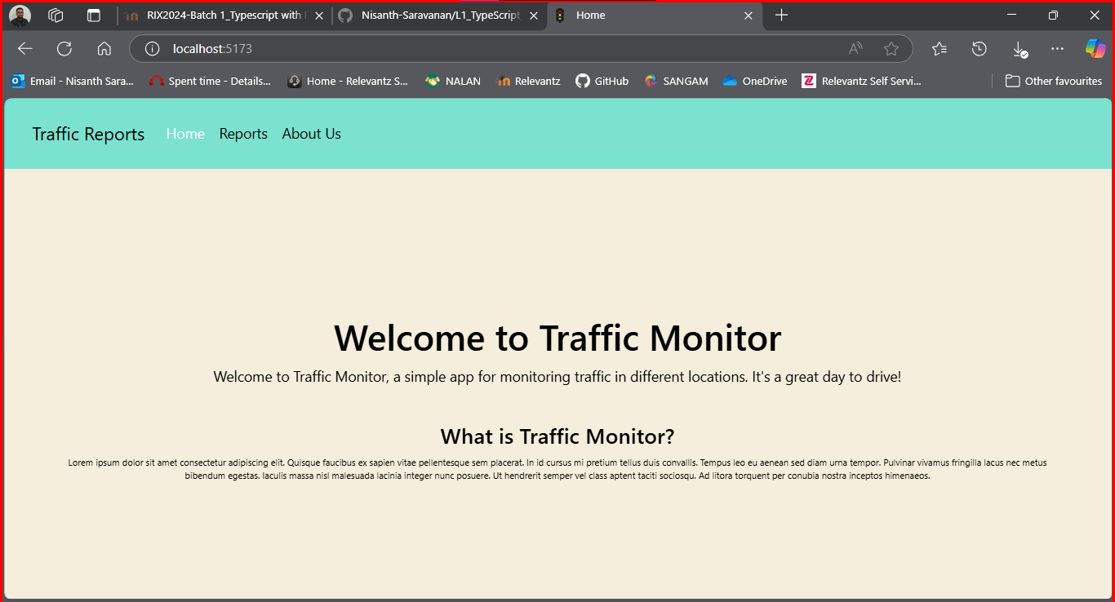

About Us Page

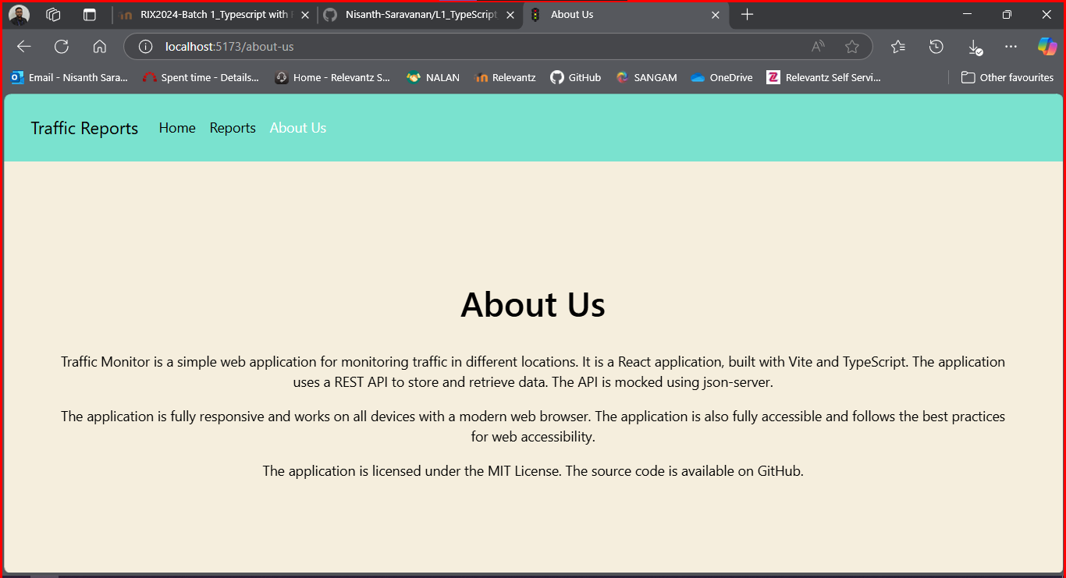
Reports Page:

No data exists in the JSON Database.

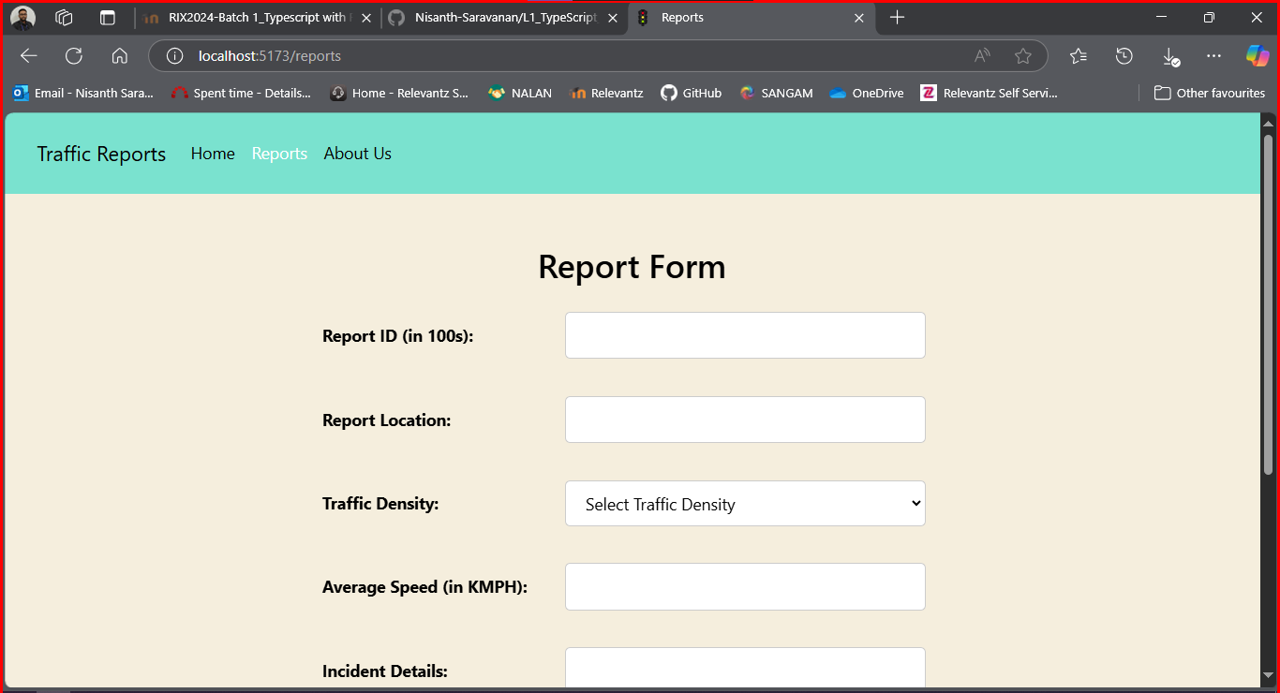

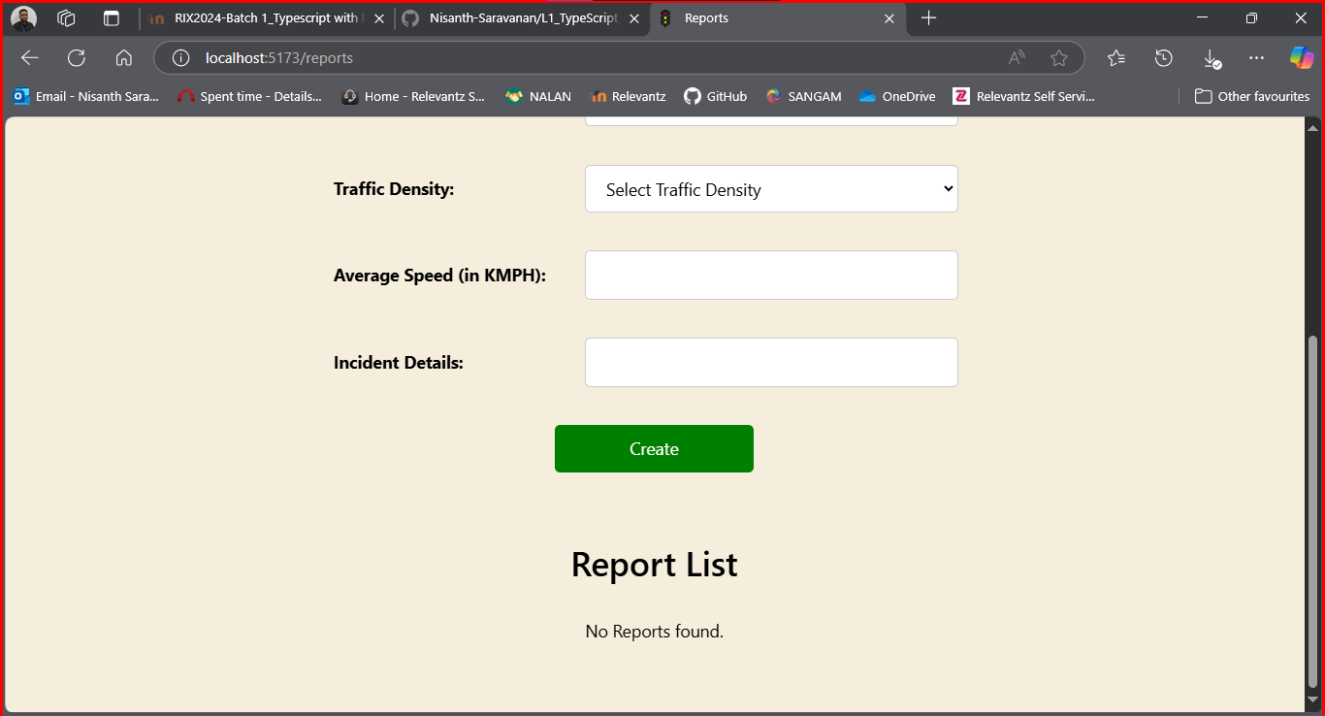
Report validations:

During Creation:

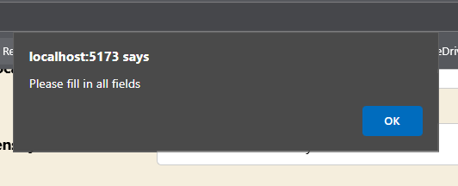

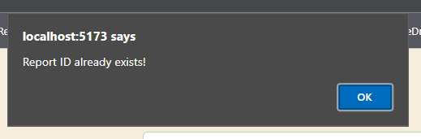

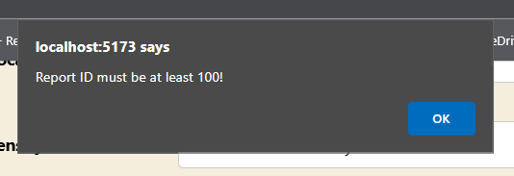

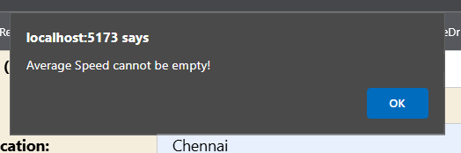
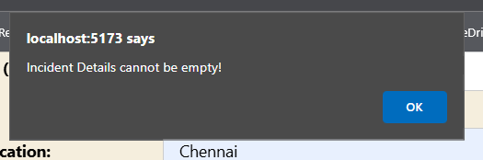

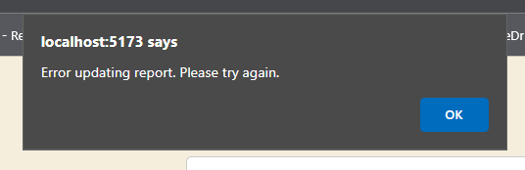

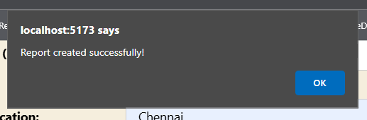
Edit Validations:

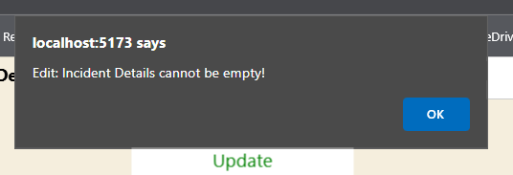

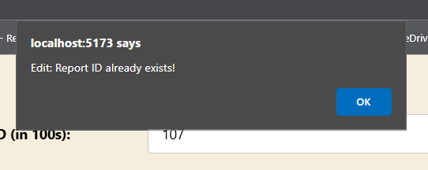

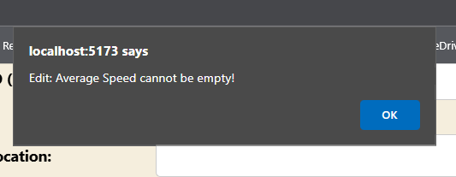

Report Creation:

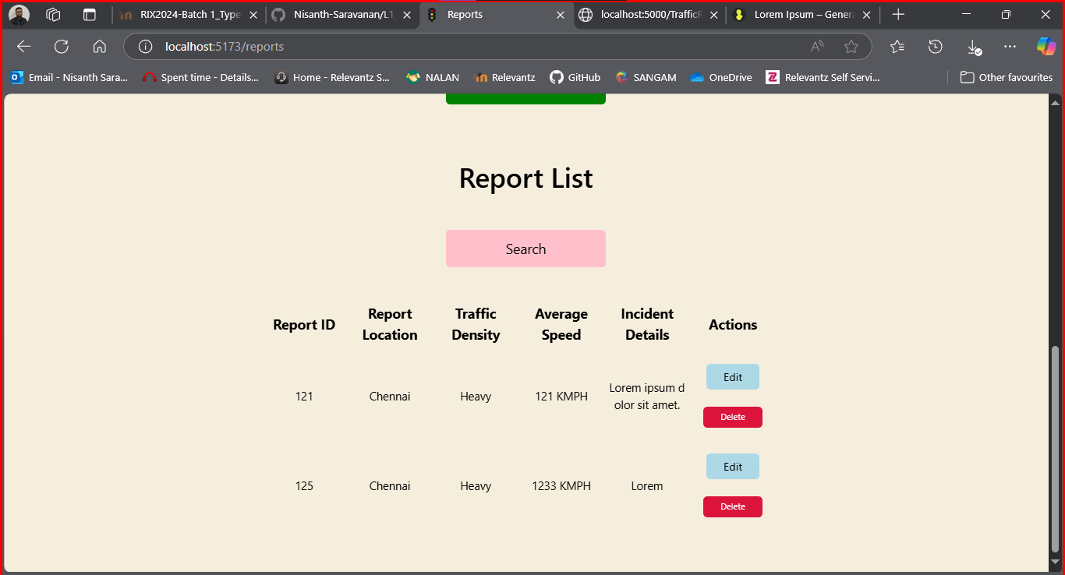

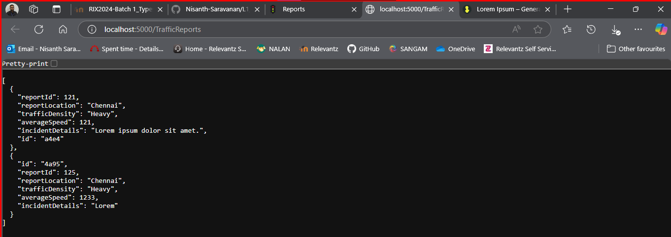
Report Editing and Validations:

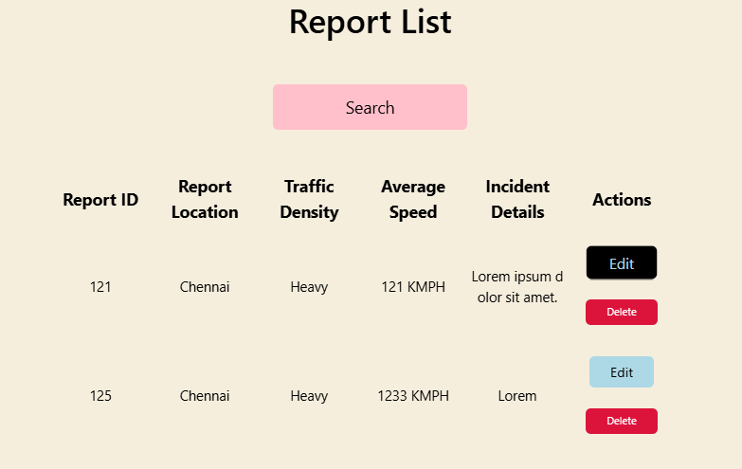

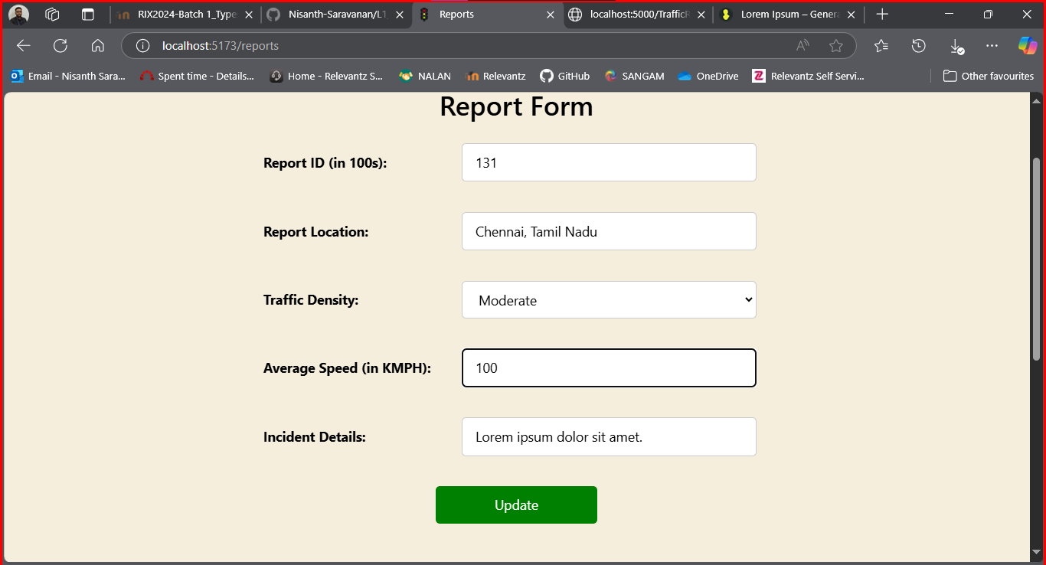

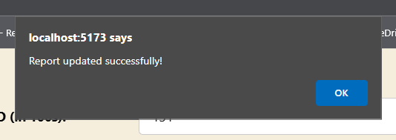

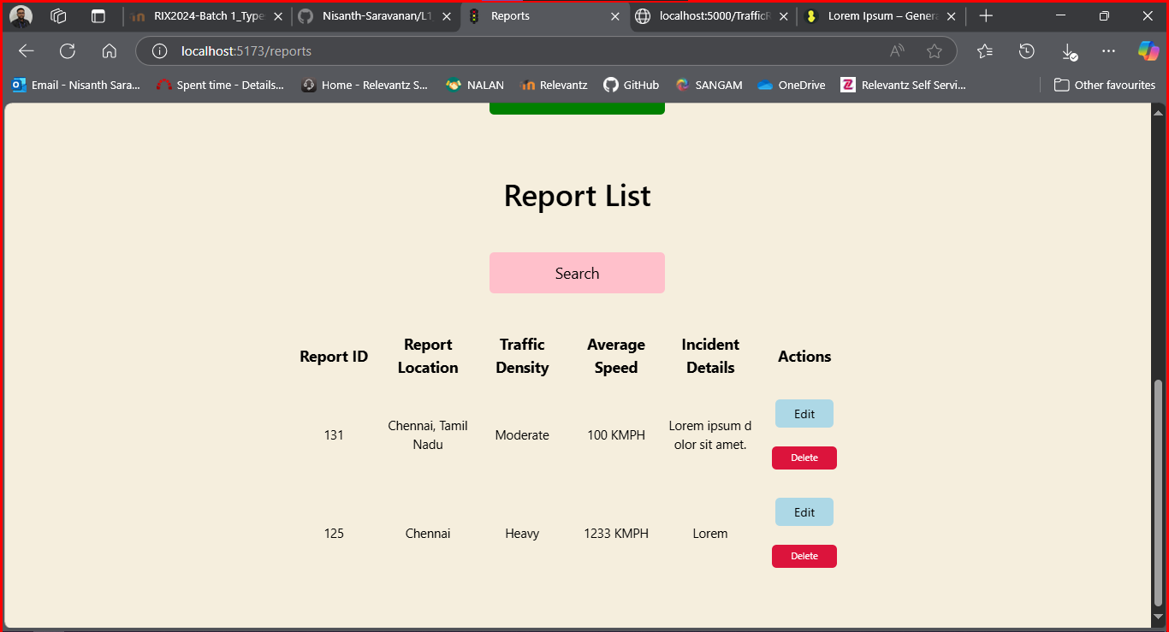

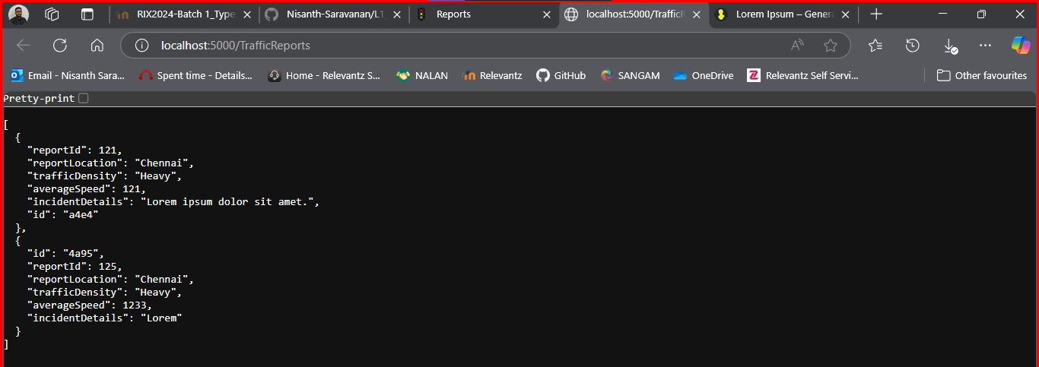

Deletion and Searching:
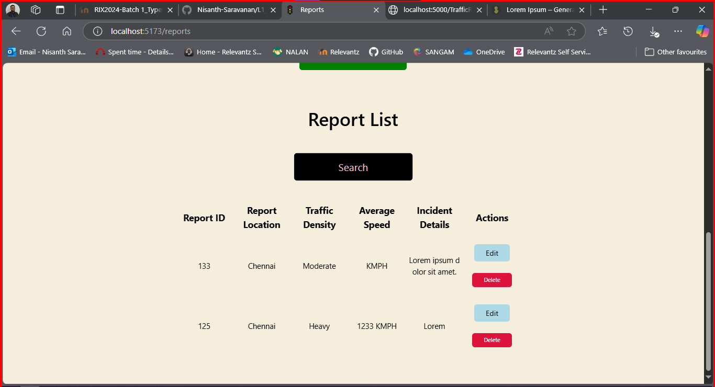

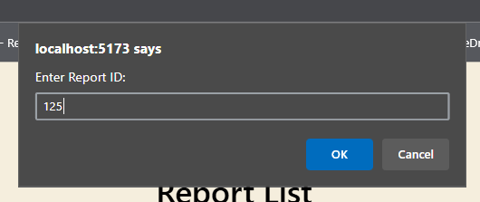

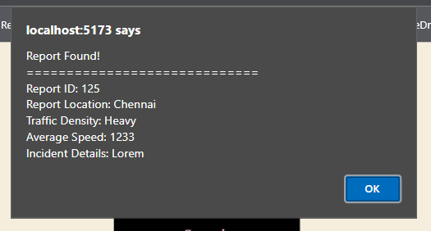
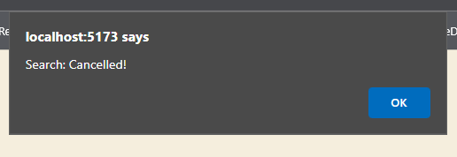

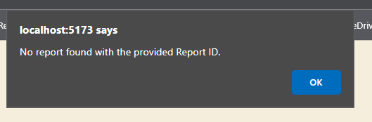

Deletion:

Before:

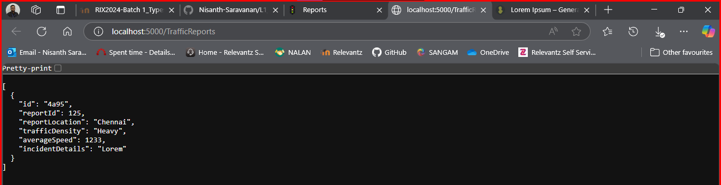

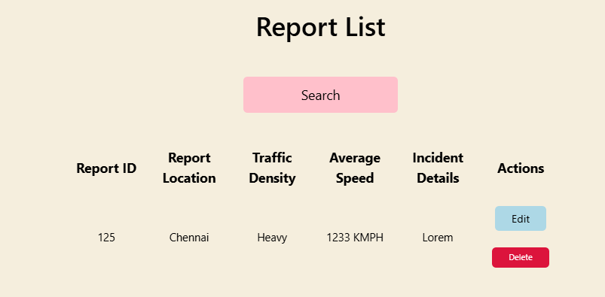
After:

